**A**

**SRS REPORT**

ON

**ONLINE AUCTION SYSTEM FOR ANTIQUE ITEMS**

**BY**

**Name of student/s and Prn**

**PROBLEM DEFINITION**

Creating an online auction system involves building a website or app where people can sell and buy items through bidding. Users should be able to register, list their products for auction, and others can place bids. The system needs to handle secure payments, provide real-time updates on ongoing auctions, and have a way to resolve disputes. It's important to make it user-friendly, secure, and able to handle a large number of users and items.

**OBJECTIVE**

The main objective of this project is building a website which will help buyers and sellers to participate in auction. Here if suppose some seller or buyer want to use this facility and learn how is it possible and how they can use Online Auction System to buy or sell the products(antique items ), they must have knowledge of computer then they can directly register in the site and sell or buy the products online.

**SCOPE**

This system is designed as an online web-based application which shall be accessed by any device, either a computer, tablet, iPad, iPhone, mobile phone or PDAs.

The scope of this application to build a user friendly auctioning website, where user will be able to auctioned any product which is available nearby or anywhere in the world. By using Online Auction management system it will be easy for auctioneer to make an auction and time saving also.

Bidders/Buyers can search for the products available in the auction and even the information about the seller

Online Auction System provides the functions which connect the sellers and the bidders efficiently.

Online Auction System could be maintained by Administrator.

**OVERVIEW**

Anyone can use the portal and browse the available products, but in order to make a purchase or place an order, a user needs to log in using their unique email and password. By visiting the registration page, unregistered members can do so. The default role is "User" when a user registers with the website.

This proposed system can be used by any naïve users and does not require any educational level, experience, or technical expertise in the computer field. However, it will be of good use if the user has good knowledge of how to operate a computer.

Online Auction System is the public web application.

There are mainly two types of users. One is the Buyer or Bidder and other is Seller.

**Functional Requirement**

This section provides a requirement overview of the system. Various functional modules that can be implemented by the system will be:

Online Auction System consists of three modules described as bel

Seller Module

Bidder Module

Admin Module

3.1 Seller Module

Seller can register and create his own account.

Online Auction System provides the function which allows Sellers to add their products for auction.

Seller can set base price for the product added.

The Seller can end the auction.

The Seller can see the current bid price on the product added. seller can give answers of buyer questions

3.2 Bidder Module

Bidder can register and create his own account.

Online Auction System provides the function which allow buyers to bid on product and see the description of product.

bidder can see sellers rating for authenticity

Bidder can rate the product and seller

buyer can ask questions

3.3 Admin Module

Online Auction System should provide all functions to admin how to handle the System.

Admin can check KYC and authorize bidder/buyers and sellers based on Government Identity proof.

Admin can verify every product before it goes for auctioning.

Admin can remove fraud Sellers and Buyers.**Non-Functional Requirement**:

**Performance**

The server must be able to support an unlimited number of devices, i.e., it must place no restrictions on the number of gadgets that can be used simultaneously.

A limitless amount of active client payments must be supported by the server, and payments must never be lost.

**Security**

Registered farmers will be allowed to place an order.

Sensitive data will always be transmitted with encryption. The system will internally maintain a secure communication channel between servers (web servers, application servers, database servers).

**Reliability**

The system should be scalable, with the ability to accommodate a large number of users at once.

The site's response time should be as quick as feasible, and it should be able to load balance the server.

**Availability**

This application is available for 24 hrs anywhere, anytime.

**Maintainability**

A Commercial database software will be used to maintain System data Persistence.

A readymade Web Server will be installed to host online shopping portal (Web Site) to management server capabilities.

IT operations team will easily monitor and configure the system using Administrative tools provided by Servers.

Separate environments will be maintained for the system for isolation in production, testing, and development.

**Efficiency**

The system will be able to manage all transactions with isolation.

**Accessibility**

Users will have no limitations for accessing the application through Internet. The portal being an internet application, it is difficult specify exact number of visitor or users. Hence we will target the system to support multiple users .

**Scalability**

Online auction portal will be secure from malicious attacks.

Online auction portal functionalities are protected from the outside with proper configuration.

Online auction portal will always be kept updated with the latest antivirus software.

Business data will be backed up periodically to ensure the safety of data using an incremental backup strategy.

Role-based security will be applied for Application data and operations accessibility.

**BENEFITS**

Online auctions facilitate price discovery by allowing buyers to bid based on their perceived value of an item. The final winning bid reflects the market's assessment of the item's worth. Market Reach:

Online auctions provide a broader market reach, allowing sellers to connect with a global audience. This can lead to increased competition and potentially higher prices for items. Efficiency:

Compared to traditional auctions, online auctions can be more efficient. They reduce the time and geographical constraints associated with physical auctions. Data and Analytics:

Online auctions generate a wealth of data that can be analyzed to understand buyer behavior, market trends, and the performance of different items. This information can be valuable for sellers and the auction platform. Dynamic Pricing:

Prices in online auctions can be dynamic, adjusting in real-time based on bidding activity. This allows for a more flexible pricing model compared to fixed-price sales. Diversity of Items:

Online auctions can accommodate a wide range of items, from rare collectibles to everyday goods. This diversity attracts a broad audience with varied interests. Competitive Bidding:

The competitive nature of online auctions can result in higher prices for sellers. Bidders compete with each other, driving the final bid closer to the true market value of the item.

**DFD DIAGRAM**

DFD LEVEL 0

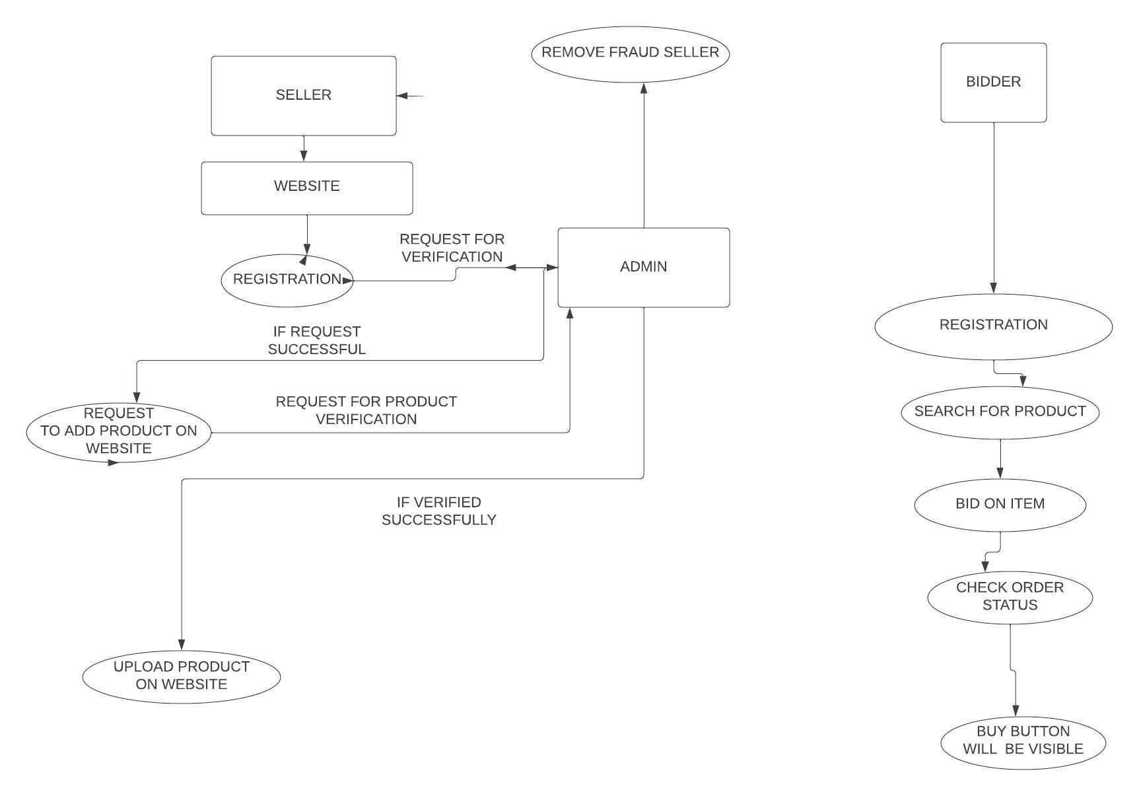

**DFD LEVEL 1**

ER DIAGRAM

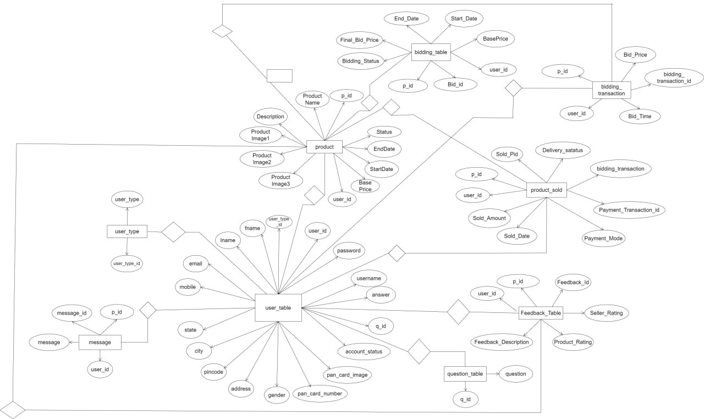

USE CASE DIAGRAM

CLASS DIAGRAM

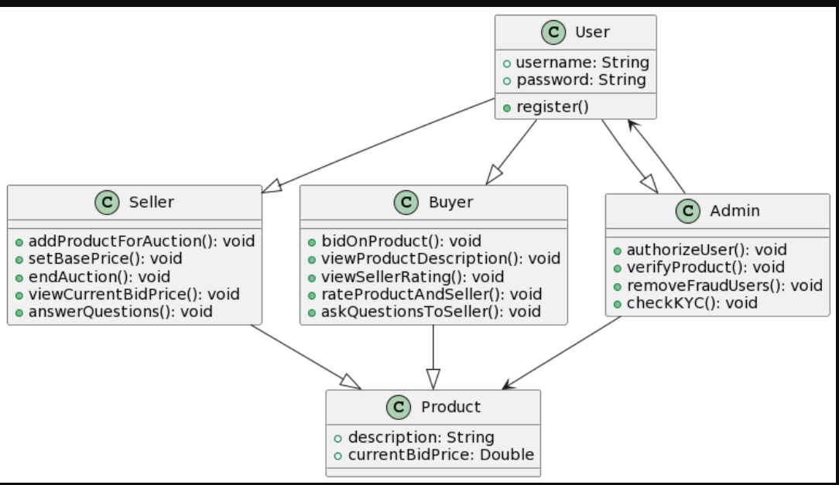

SEQUENCE DIAGRAM

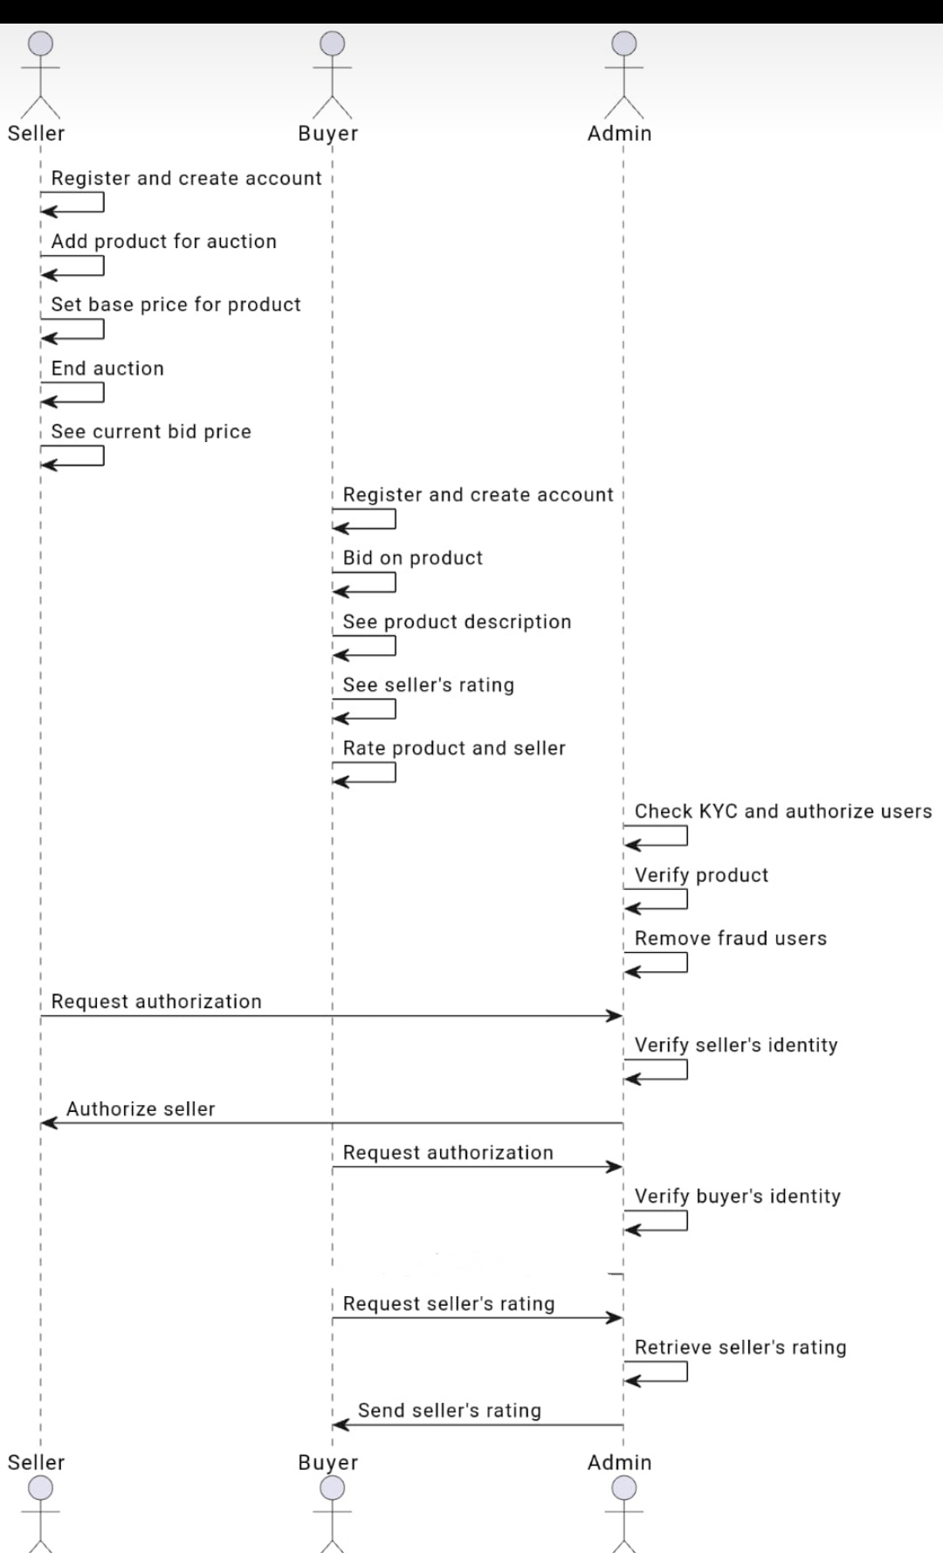

SELLER ACTIVITY DIAGRAM

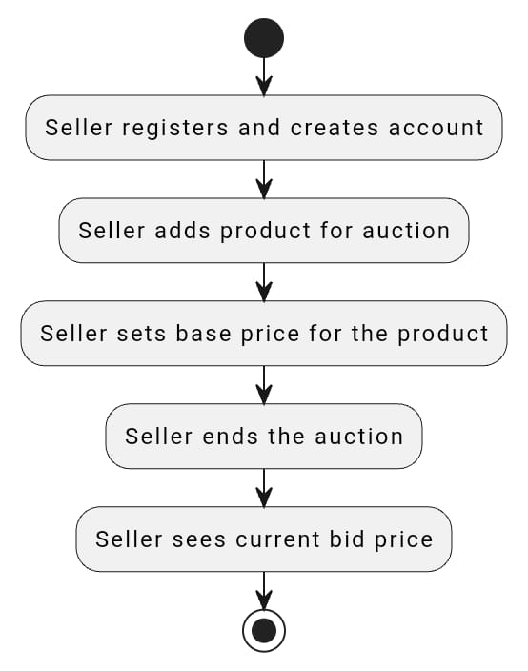

BUYER ACTIVITY DIAGRAM

ADMIN ACTIVITY DIAGRAM

